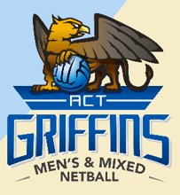

COACHES WANTED
2022 GRIFFINS REPRESENTATIVE PROGRAM
All ACT Coaches and Assistant Coaches – Applications are now open for all Coaching positions for our 2022 State teams to participate in the Australian Men’s and Mixed Netball Championships in Adelaide.
We are looking to engage only those enthusiastic, experienced, and committed coaches that share our vision to see the ACTMMNA Griffins teams strive to be high performing and competitive at Nationals.
What we are looking for:
- Coaches and Assistant Coaches with experience coaching at the State representative level and/or at State League Level, or those who are keen to gain experience in our state representative program.
- Qualifications including Netball Australia Accreditation, or a willingness to work towards Development, Intermediate and Advanced Accreditation within the ACT Griffins program and Netball ACT pathways is highly desired.
- Coaches that will commit to all squad and team activities over the period between late November 2021 until the completion of Nationals in April 2022.
- Highly developed people skills and an ability to work cohesively with other squad coaches and program management
- Personal strength and character to establish and instill the ACTMMNA vision, culture, and standards always, and
- A current Driver’s License and ACT Working with Vulnerable People Registration.

Duty Statements and information on how to apply is available on our website: www.actmensandmixednetball.org.au

Applications Close: Sunday 7th November 2021
Should you have any questions or require further information, please contact Sheree our Vice-President of Game Development at: actmensnetball.vpgamedev@outlook.com or on 0419 530 233 (outside of business hours).

